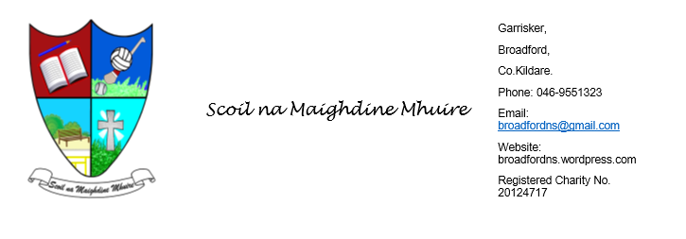

Welcome Back
We hope you all had a lovely and relaxing Easter break and that the children are returning refreshed and ready for a busy term ahead!

First Confession 
A special mention to our 2nd Class boys who will be making their First Confession tomorrow. We wish them the very best of luck on this important step in their journey.

Tractor Run – Next Sunday 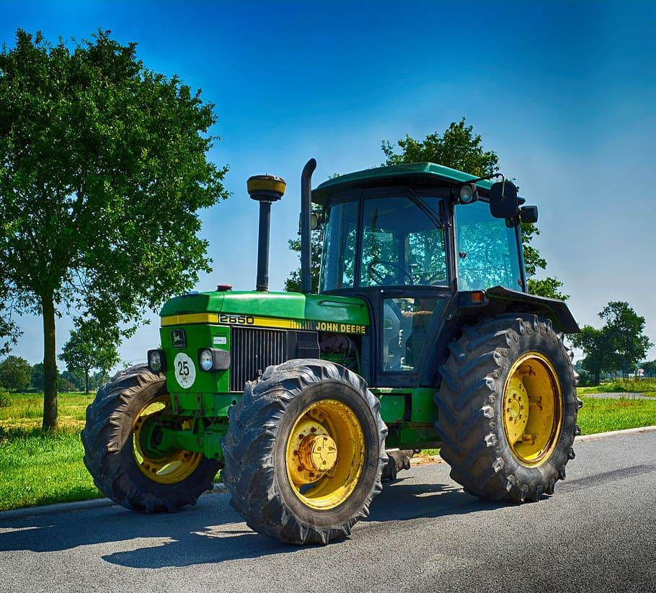
We are really excited about our Tractor Run taking place next Sunday.
We would love your support—please spread the word to anyone you know with a tractor and encourage them to come along.
There will also be a mini tractor run for children, so they are very welcome to bring along their own toy tractors or vehicles to join in the fun!
A bake sale and raffle will take place on the day, with some fantastic prizes up for grabs.

School Activities & Achievements 
Well done to all the children who represented the school before Easter:
- Congratulations to those who took part in cross country
- Well done to our pupils who participated in the Community Games chess in Clogherinkoe.
- A big well done to the girls who represented the school so proudly in the soccer blitz and camogie blitz.
- Next event is : 21st April – Boys’ Football Blitz

School Website
Our website is up and running so please have a look. There are a few photos there from some recent school events too. You might spot someone you know!

🎭 Scór na bPáistí
An upcoming Scór na bPáistí event will take place in Athea Wood GAA Hall next weekend (18th).
Children can take part in:
- Céilí dancing
- Solo singing
- Recitations
- Ballad group
- Novelty act
- Instrumental group
- Set dancing
If your child is interested in taking part, please let us know and we will forward names on.
🕑 The quiz will take place at 2.00pm, followed by competitions starting at 3.00pm.

Small Schools in the Dáil
Following recent communication with a number of local TDs about the challenges faced by small schools, we were very encouraged to receive some positive feedback.
Our school was mentioned in Dáil Éireann by Naoise Ó Cearúil during questions. Joe Neville has since visited the school, and Jim Lawless has also been in touch.
This work is about raising awareness for the future, but it is reassuring to know that our school and its needs are now recognised. Have a look at the other link attached.

School Inspection Update
We are delighted to share that our recent school inspection report has come back very positively.
The quality of teaching and learning in English was highlighted as good, and the children received wonderful praise for their behaviour, engagement, and positive attitude to learning. We are very proud of this feedback.
The full report will be available online within the next 8 weeks.

There will be mechanical works carried out in the school over the coming weeks. These will be carried out in the evenings when school is over. If you see lights on or activity around the school please don’t be concerned.
Thank you, as always, for your continued support.
Mary Carr.
