Newsletter
18th Feb 2026

Dear Parents and Guardians,
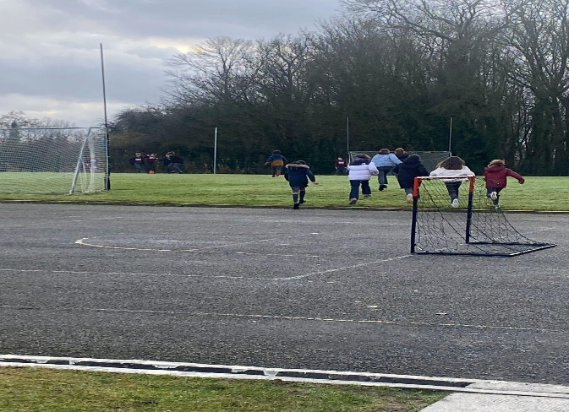
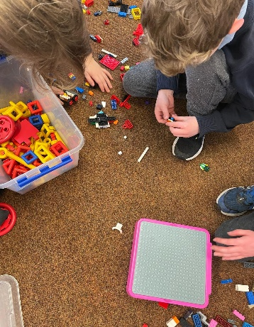
As we come to the end of another busy term, I just wanted to take a moment to say that I am really settled in now and feeling very much at home here in Broadford. So much has happened over the past few weeks, and it feels like I have been for the whole school year.

Visit our School!
We are keen to continue spreading the word about our lovely school. On Wednesday 25th February, parents of children who may be starting Junior Infants are very welcome to come in, visit the Junior Infant room, chat with the teacher, and have a chat with me about our plans for the future. Please spread the word to anyone you think might be interested.
Tractor Run
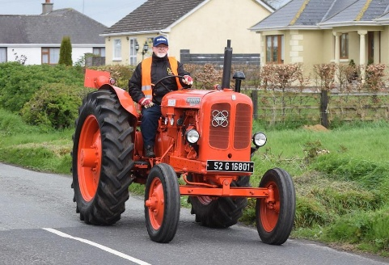
Please save the date for our Tractor Run on 19th April. It will be a great day, with a raffle and some lovely prizes, as well as tea, coffee and cakes on the go. We’d love to see a big crowd, so please spread the word to any farmer friends or anyone with vintage cars who might be interested. Even if you’re not taking part, do come along if you can and help us wave them off!

A Busy Term
Our pupils have been as busy as ever. Well done to those who took part in the Credit Union Quiz, and an even busier one to come! Some children enjoyed Pancake Tuesday, there were plenty of smiles in Ms Cullagh’s room! (and pancakes!) all round.
Assembly
We had an assembly this morning to mark Ash Wednesday and the start of Lent.
We have a beautiful Bí Cinealta Flag to put up outside, to show we are a school who are engaging with the National Policy of Bí Cinealta - an anti bullying strategy.

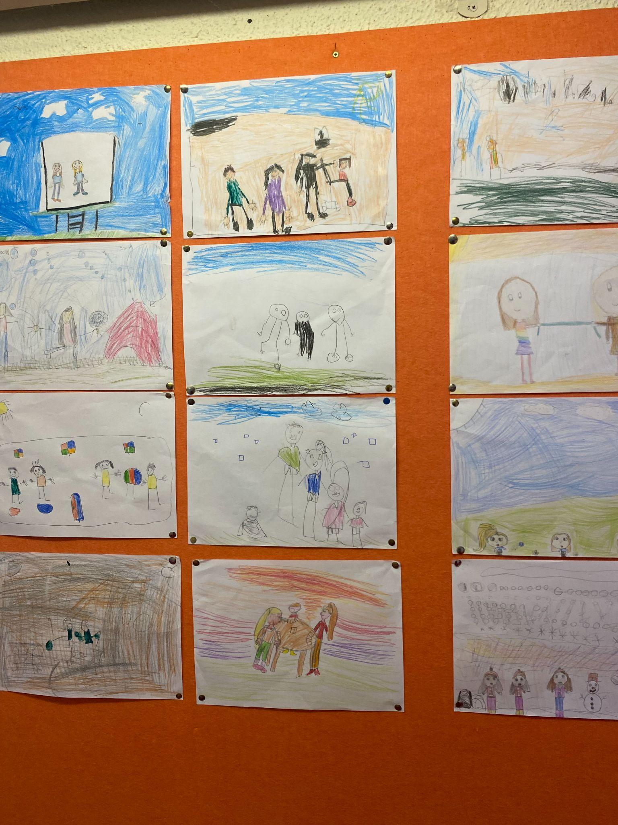
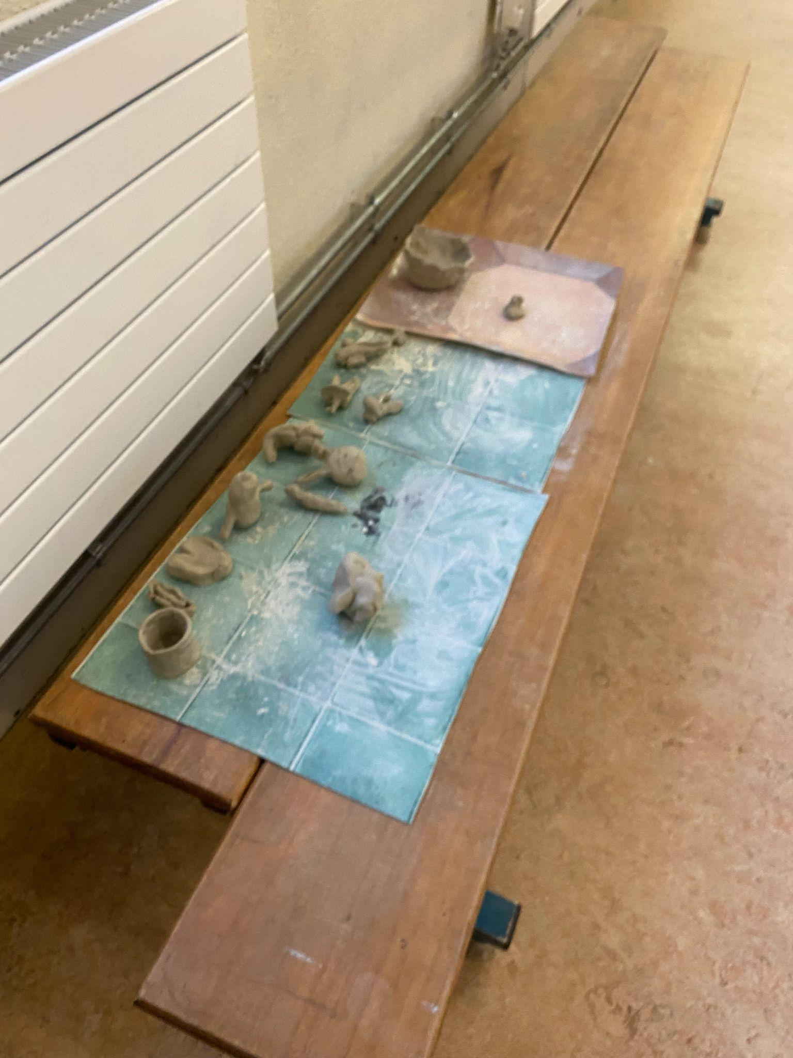
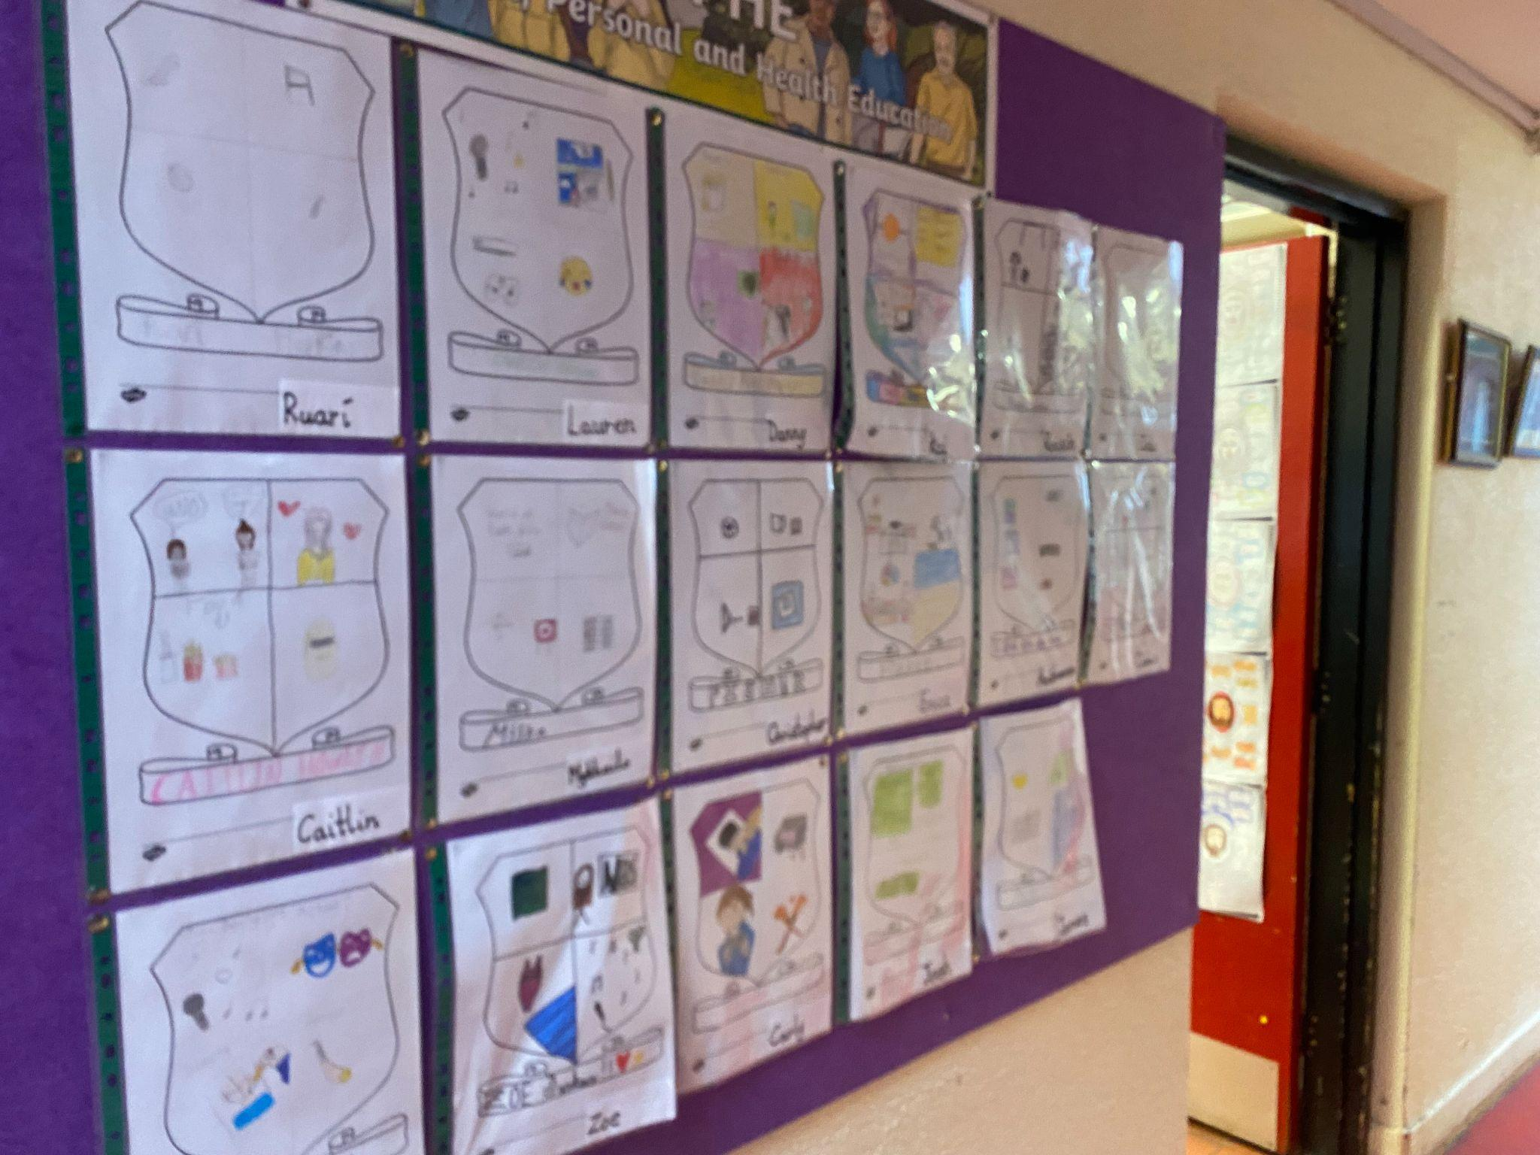
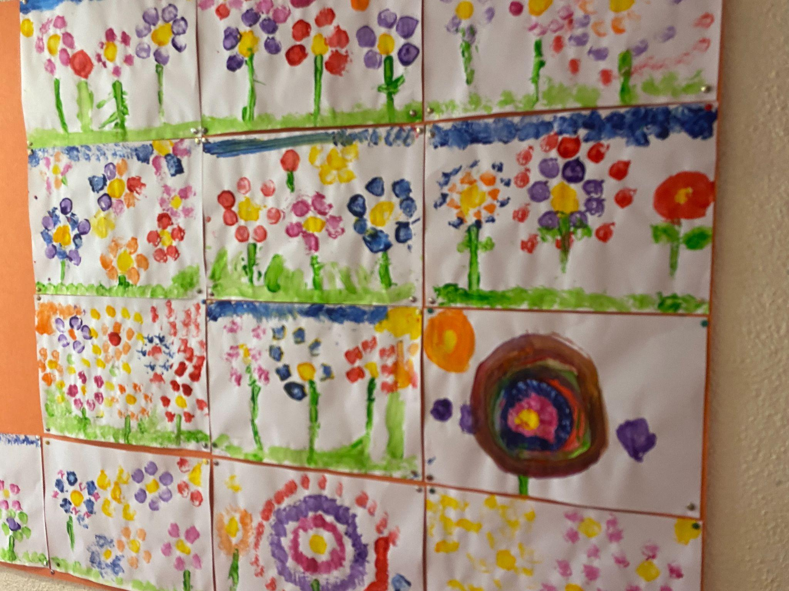
Our Corridors are filled with colour, showing off all the wonderful work being done inside the classroom.
Reminders for Parents
- Please remember our Cash for Clothes collection —25th March
- Our 50/50 draw is ongoing and very much appreciated
- 6th class retreat 5th March
- Confirmation 12th March
- Tractor run 19th April
Website Update
A quick note on our website: our current website will shortly be shut down as we move towards launching a brand new one. Keep an eye out, we are hoping the new site will be up and running within the next couple of weeks.
Thank you, as always, for your continued support and kindness. I hope everyone enjoys a restful and well-deserved break, and I look forward to seeing you all again next term.

Warm regards,
From, all the Staff here in Broadford NS!

